

BPM Admin Tools

**Documentation**

Created by

**Juan Camilo Parra Martínez**

[jcparra@co.ibm.com](mailto:jcparra@co.ibm.com)

Introduction 3

Snapshot Installer (Export/Install) 4

JS Console (JavaScript Console) 6

Manage Calendars (Holidays and Time Schedule) 8

Manage Groups 11

Introduction

This process app is and admin tools that pretend to extend some functionality on IBM BPM 8.0.x and 8.5.x helping with the most typical administrative tasks.

U**se this tools on your own risk.**

Snapshot Installer (Export/Install)

This tool is basically a way to export and install snapshots using and user interface.

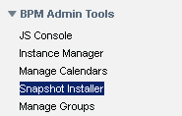

**Authorization**

To access this tool you have to be member of BPMAdminTool_Snapshot_Installer

More authorization is required, you need a WAS or BPM user that allows to install a snapshot

This tools works using wsadmin to install

**Mode of use**

This tool has two mode of use, on Process Center, you can export a Snapshot on a specific directory.

But on Process Server, you can import it.

***Export***

To Export select project to export

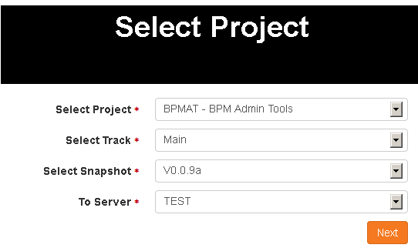

Set a user and password that can export the snapshot, It doesn’t have to be the same user that are logged into

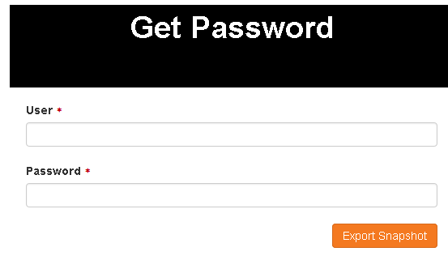

If you detect some issue on output solve it and try again, otherwise download file from server.

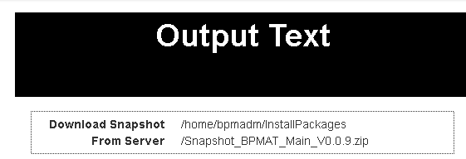

JS Console (JavaScript Console)

This interface is a JavaScript Console allow you to evaluate javascript functions, usefull to check info on process servers that are on offline mode.

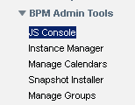

**Authorization**

To access this tool you have to be member of BPMAdminTool_JSConsole

**Mode of use**

This tool works as the process inspector evaluator, doesn’t autocomplete, and results are returned very similar to process inspector return it.

This tool execute JavaScript Code, so be carefull with authorizations and code executed.

***Execute***

Just write the command or commands and execute it, just as you use process inspector, remember this utility is not associated with any instance so there are some commands that could not be executed directly.

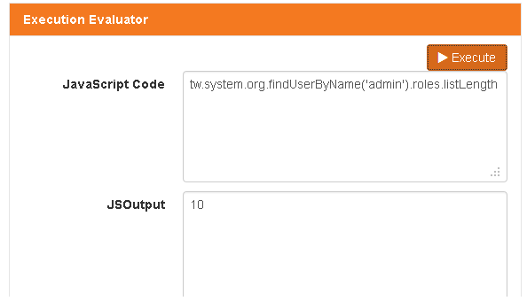

This is a multiline example

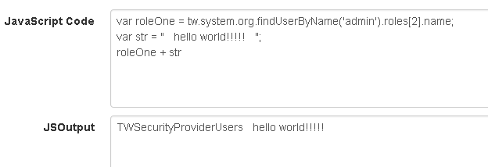

Manage Calendars (Holidays and Time Schedule)

This tool is a re write Manage Calendar build or published on wiki by Gordon Siegfriedt it is adapted from http://wiki.bpmwiki.com/display/commwiki/Manage+Time+and+Holiday+Schedules

I try to contact Gordon Siegfriedt but it was not posible, so I only take the concept from him, but I didnt copy the code.

Gordon Thanks for your contribution to the Wiki.

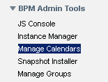

**Authorization**

To access this tool you have to be member of BPMAdminTool_Calendar_Manager

**Mode of use**

This tool allow user to modify Holidays and Time Schedule on BPM

***Principal page***

Here you can select between Manage Time Schedule and Manage Holidays

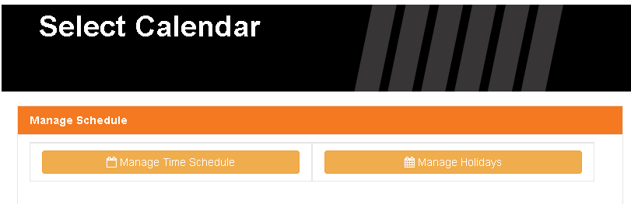

***Manage Time Schedule***

You can Add a new Time Calendar, modify one or remove

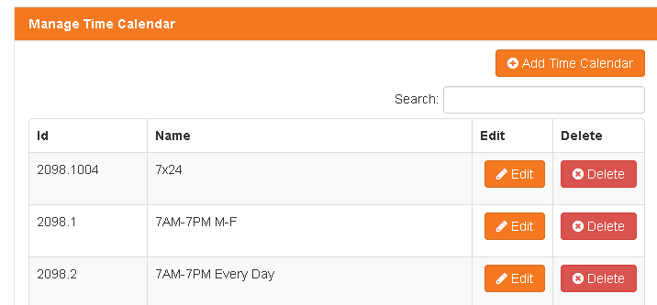

Deletion needs confirmation

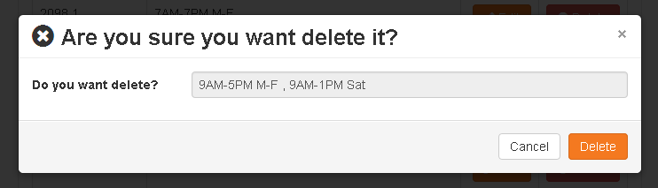

Modify one is very simple and intuitive

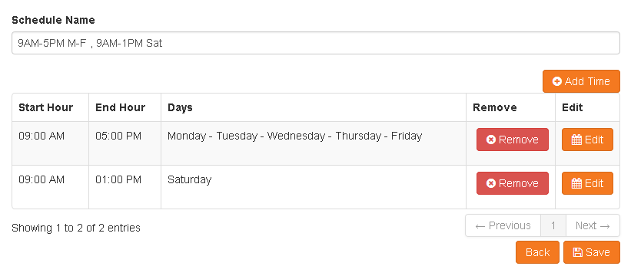

Only after click save and confirm, calendar is saved.

***Manage Holidays***

You can Add a new Holiday Calendar, modify one or remove.

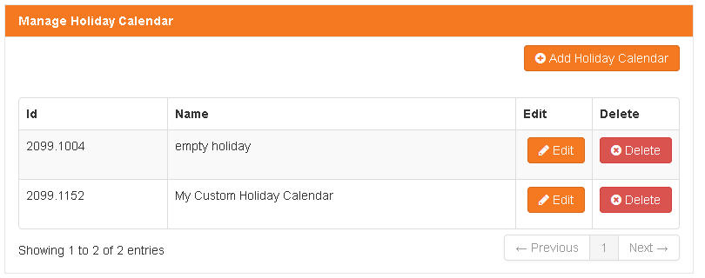

Deletion needs confirmation

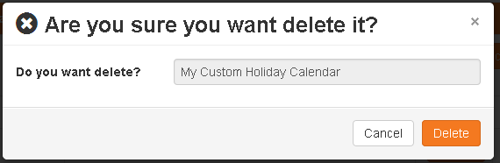

System is used to format date, you can change format using environment variables.

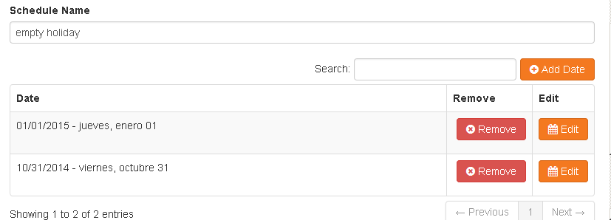

Manage Groups

As you can evidence there is no way to use product group manager tool with out be a tw_admins.

There is some customers that and area is the responsible to manage users and groups, but not the administrator of platform.

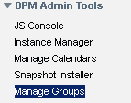

**Authorization**

To access this tool you have to be member of BPMAdminTool_Manage_Groups

The person on this group can modify all groups inside on BPM except those one inside BPMAdminTool_Manage_Groups_Excluded on this way if group tw_admins is member of BPMAdminTool_Manage_Groups_Excluded, the user cannot modify tw_admins

By default user cannot modify tw_admins and tw_process_owners, and there is no way he can modify tw_all_users

**Mode of use**

This tool has to ways of use, first one is by script second one Is by user interface.

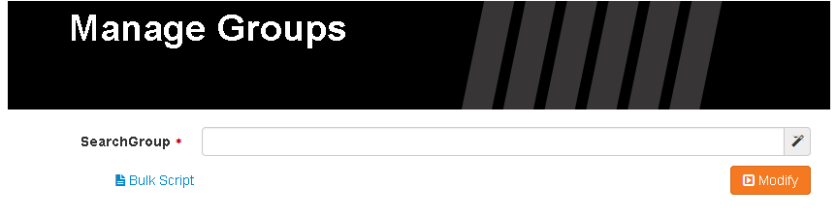

***Modify By Script***

Click on Bulk Script and paste your script on left side

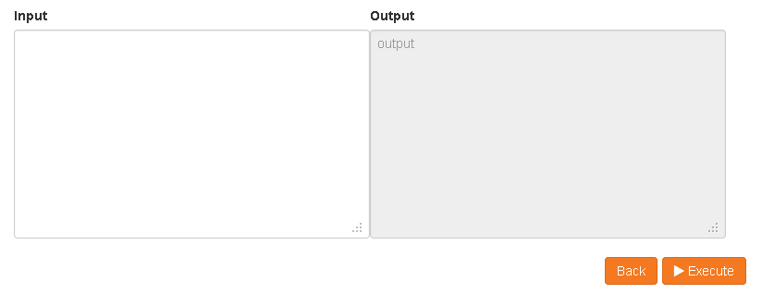

Script is very simple just follow this simple rule

< add | rm > < grp | usr > childName < from | to > grp parentName

Example

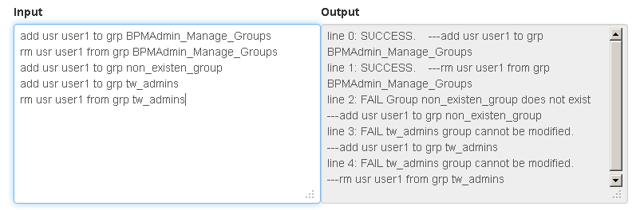

If you need to use a group name with spaces just use html character &nbsp; example

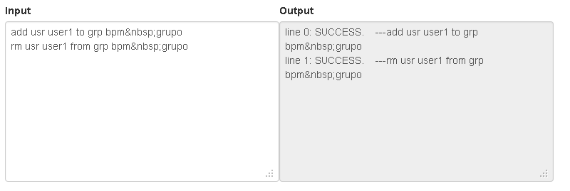

***Modify By UI***

You can to use UI to change groups, just you have to write some characters to select group to change, and click modify

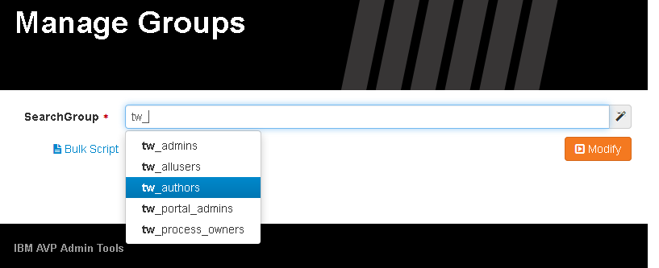

You can add or remove members and groups from this group

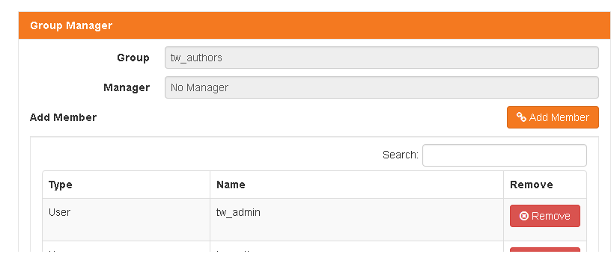

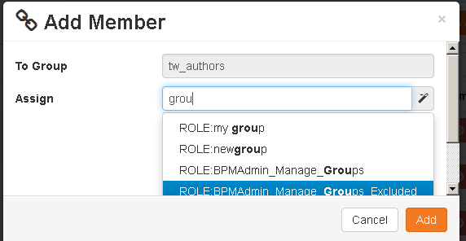

Instance Manager

This tool is a little Process Inspector, that allows to check instances, states, failed, retry, etc. usefull when process server is on offline mode.

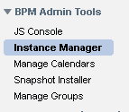

It works on a complex way, because you can allow some person to access just a single process app, you can reassign a single task or view the BPD business object, but all of this functions has differents privileges to be performed.

I want to thank Sergio Gutierrez, it was a mutual idea, he performed the first approach of this, and now it is a complex and usefull Instance Manager.

**Authorization**

To access this tool you have to be member of BPMAdminTool_Instance_Viewer, with this privilege you can access but you cannot perform any activity, this is required by all members that has to access this console.

BPMAdminTool_BO_Viewer is a rol to access BPD level Business Object, people that have this privilege can see the object but no modify it.

BPMAdminTool_Reassigner is a rol that allow to reassign active task on instance, without this role this action cannot be performed.

No roles can access any project by default, the authorization has to be given user by user, only the BPMAdminTool_Project_Inspector_Admin can modify this authorization, please refer Giving Access To Specific Project below.